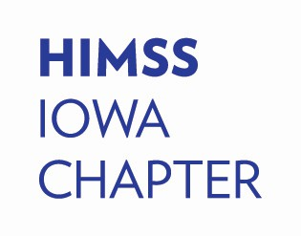Iowa HIMSS Sponsorship Overview

# WHO IS IOWA HIMSS?

The Healthcare Information and Management Systems Society (HIMSS) is a global, non-profit organization committed to advancing healthcare through the power of information technology. Join us, as a board member or a participant, in Iowa to take a leading role in optimizing health engagements and improving care outcomes.

Our HIMSS Iowa Chapter hosts a variety of events featuring expert speakers, insightful presentations, and a range of educational activities. We also deeply appreciate our dedicated volunteers who contribute their ideas and leadership, and enjoy exceptional opportunities for professional development, networking, and active engagement. Come be a part of a community that’s shaping the future of healthcare.

# WHY SPONSOR?

The Iowa HIMSS Chapter offers a diverse range of sponsorship opportunities tailored to meet the unique needs of different organizations, regardless of budget, resources, or availability. We understand that each sponsor has specific goals, so we have designed flexible options that allow you to choose the most suitable package for your objectives. In addition to our traditional sponsorships, we’ve recently introduced several new services to provide even greater value and visibility for our partners.

Furthermore, we are actively collaborating with other HIMSS chapters to broaden your networking opportunities and expand your reach within the healthcare IT community. These partnerships will help you connect with a wider audience and foster valuable relationships across the region. We are also committed to continuously improving and evolving the benefits we offer to our members, and we are open to any suggestions or feedback that would enhance your Iowa HIMSS Chapter experience. Our goal is to ensure that your involvement with us brings maximum value, and we look forward to working together to create meaningful, long-term connections.

# SPONSORSHIP OPPORTUNITIES

**Elite** – Annual Sponsor, 4 available per year.

**Premier** – Table Sponsor, unlimited availability based on space, at each event.

**Hospitality** – Sponsor, 4 available per event.

**Social Event** – Sponsor, 1 available per event.

iowa.himsschapter.org

[iowa.info@himsschapter.org](mailto:iowa.info@himsschapter.org)